Types of Solar **Rooftop Power Systems**

Photovoltaic or PV power systems are generally classified according to their operational and functional requirements, their component configurations, and how the equipment is connected to other electrical loads and power sources.

The two principal classifications are grid-connected systems and the second is Off Grid systems. The types of Solar PV (Photovoltaic) Systems are as follows

On-Grid  System or Grid-tied System

A grid-tied system is the most widely used solar system. Best suited for people having access to the utility grid and want to reduce their monthly electricity bills.The system is designed to work in conjunction with the grid. The electricity that you generate is fed back to the grid. A net meter is installed along with the system to keep track of the electricity consumed by you versus what you have generated and fed back, resulting in savings that gets reflected in the bill. For safety reasons, the system does not work during power failures.

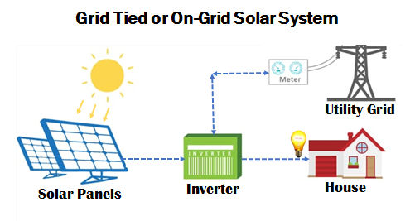

Off-Grid  System

These type of systems are used in areas facing frequent power cuts and have no access to the utility grid or DISCOM.These systems stores electricity produced by conversion in batteries and utilise the stored energy by converting it back to AC as and when required.

The increasing demand for these types of systems over years has brought the system cost down.

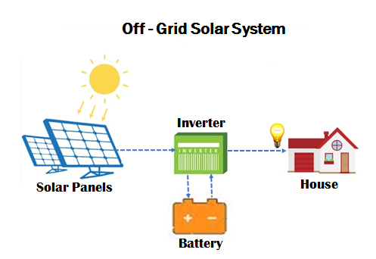

What is a **Rooftop Solar Power System all about?**

**Solar Panels:** Solar panel comprises multiple PV( photovoltaic )cells that convert sunshine to electricity. Based on the area available for solar installation, the required capacity of solar panels can be calculated. There are two types of PV Panels used for rooftop installation- Polycrystalline and Monocrystalline

1. Polycrystalline :

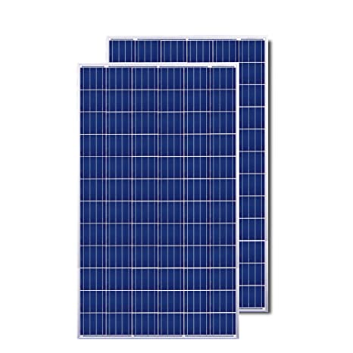

* Polycrystalline solar panels have solar cells made from many silicon fragments melted together.
* They are less expensive to produce and more suited for Indian conditions.
* They have an efficiency of around 15-17%

1. Monocrystalline :

* Monocrystalline solar panels have solar cells made from a single crystal of silicon.

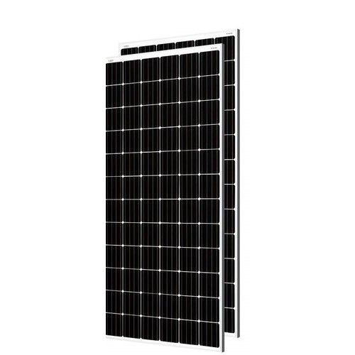

* In appearance, they have a smooth texture and you will be able to see the thickness of the slice.
* They have an efficiency of around 18-20%

**Inverter:** The inverter is the heart of a Solar Pv System. It acts as an interface that converts power produced by solar panels into electricity, that can be consumed by appliances. The type of inverter being used depends on the kind of solar power system you are going for. Grid-tie solar power systems need high-efficiency power inverters that can feed power from solar panels directly to the grid for optimizing its performance. They are designed to quickly disconnect from the grid if the utility grid goes down (anti-islanding) as a safety feature for the linesman working on the grid. Another kind of high-efficiency solar inverters is there for the off-grid solar power system that can charge batteries both from solar and grid power. The inbuilt MPPT (Maximum Power Point Tracking) charge controllers in some good quality inverters extract up to 30% more power from solar panels.

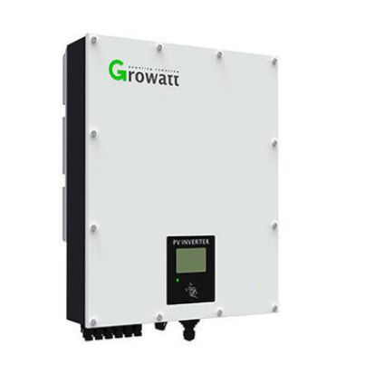

**Mounting Structure:** It is the most critical part as it acts as the skeleton for the entire system, a sturdy structure will result in years of power generation as it needs to withstand strong winds and other natural forces. The type and orientation of the structure varies to a great degree depending on multiple factors associated with the location where the solar power system needs to be deployed. The structure for rooftop solar installation on a flat roof is completely different than that for a slanted roof. The height of your roof is another major factor that determines the composition and alignment of the structure. The quality of the material used has to be as per the MNRE (Ministry of New and Renewable Energy) specified norms. The structure needs to be made of galvanized iron, which is anti-corrosive making the solar power system last longer.

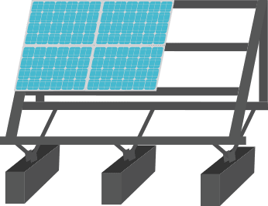

**Cables:**  Specialized cables custom made for residential solar power plants are used to ensure minimal loss of electricity being generated. They are UV protected, strong, and long-lasting enough to withstand the rigors of nature – be it peek summers, incessant rains, or thunderstorms. The use of any ordinary cable is a big safety hazard with high chances of electrocution for the people in the vicinity of the system. The bad quality wire will make your system ineffective and more expensive.

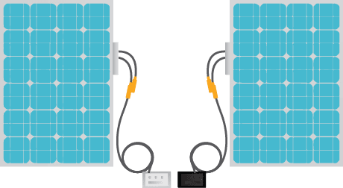

**Peripherals:** These are the elements that are essential for the proper functioning and safety of the system. No compromise must be made on their quality or it will jeopardize the entire solar power system. In terms of their functioning, while Junction Boxes are used to conceal the wiring connections all across the system, Conduits on the other hand are used to protect the wiring of the solar power plants, they can be rigid or flexible or a mix of both based on the requirement. Lightning Arrestors are deployed to save the entire set up in case of a lightning strike, especially during monsoon while Earthing, which is a grounding system connecting the residential solar power plant to earth, is done in order to give passage to excess electricity during a lightning strike and safeguarding the entire system in the process.

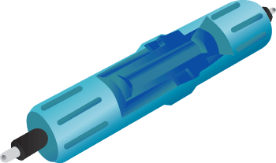

**Batteries:** Apart from these, if you are going for an off-grid solar solution, solar batteries are one of the crucial components as they allow you to store the electricity generated by the solar plant and use it in case of power outages or in case of no mains. A good battery would be the one that gives long back up and requires very little maintenance (less frequent water top-up).

